Description of Exam Four - 100 points - 75 Minutes
Multiple Choice: 26 points
- 13 questions at 2 points each
- 15 minutes

Sentence Revision: 16 points
- 4 questions at 4 points each
- 15 minutes

Sentence Creation: 16 points
- 4 questions at 4 points each
- 15 minutes

Sentence Diagrams and Labeling: 42 points
- 3 diagrams and labeling at 14 points each
  - 7 pts for each labeling table
  - 7 pts for each diagram
- 20 minutes

Bonus: 18 points – Punctuation Revision
- 6 sentences at 3 points each

Exam Two Key Learning Objectives
- Adverbials
  - Noun phrases serving as Adverbials
  - Verb phrases serving as Adverbials
  - Dependent Clauses serving as Adverbials
- Adjectivals
  - Relative Clauses
  - Verb phrases serving as Adjectivals
- Nominals
  - Complement Clauses
  - Verb phrases serving as Nominals

Section A: Multiple Choice
Question One: Which of these sentences contains a noun phrase (form) serving as an adverbial (function)? (3 pts)
Answer:_____
- In January, I will take a vacation.
- Tuesday is my favorite day.
- Next Wednesday, I will have a test.
- I love summer.

Question Two: Which of the following sentences contains an infinitive phrase (form) serving as an adverbial (function)? (3 pts)
Answer:_____
- To avoid embarrassment, Tim rehearsed his speech multiple times.
- Tim rehearsed the speech to the end.
- I don’t really like to ski.
- Tim excelled in his speech, thereby avoiding embarrassment.

Question Three: Which of the following sentences contains a present participle verb phrase (form) serving as an adverbial (function)? (3 pts)
Answer:_____
- Reflecting on your experiences is important.
- Reflecting on your experiences, I think you should apply for a promotion
- You are reflecting on your experiences.
- You hate reflecting on your experiences.

Question Four: Which of the following sentence patterns uses a past participle verb phrase (form) as an adjectival (function)? (3 pts)
Answer:_____
- I burned my meat to a crisp.
- I only eat meat that is burnt to a crisp.
- I only eat meat once someone burns it to a crisp.
- I only eat meat burnt to a crisp.

Question Five: Which of the following sentence patterns uses a present participle verb phrase (form) as an adjectival (function)? (3 pts)
Answer:_____
- The lady is walking her dog silently.
- The lady walking her dog passed by without comment.
- I know you are walking your dog.
- You really hate walking your dog.

Question Six: Which of the following sentences uses a present participle verb phrase (form) as a nominal (function) (3 pts)
Answer:_____
- I will not go to therapy.
- I am going to therapy.
- I love going to therapy.
- The man going to therapy must pay his therapist.

Question Seven: Which of the following sentences uses an infinitive verb phrase (form) as a nominal (function) (3 pts)
Answer:_____
- To make things clear, I explained more thoroughly.
- To make things clear is never easy.
- You are not the one to make things clear.
- I know you are the one to make things clear.

Question Eight: Which of these answers best describes the underlined portion of the sentence below?
Sentence: The money foolishly gambled away by her father had been saved to buy her sister’s braces.
- A relative clause serving as an adjectival
- An appositive serving as an adjectival
- A present participle verb phrase serving as an adjectival
- A past participle verb phrase serving as an adjectival

Question Nine: Which of these answers best describes the underlined portion of the sentence below?
Sentence: The money that her father foolishly gambled away had been saved to buy her sister’s braces.
- A relative clause serving as an adjectival
- A complement clause serving as an adjectival
- A present participle verb phrase serving as an adjectival
- A past participle verb phrase serving as an adjectival

Question Ten: Which of these answers best describes the underlined portion of the sentence below?
Sentence: The money that her father foolishly gambled away had been saved to buy her sister’s braces.
- A relative clause serving as an adverbial
- A complement clause serving as an adverbial
- A prepositional phrase serving as an adverbial
- An infinitive verb phrase serving as an adverbial

Question Eleven: Which of these answers best describes the underlined portion of the sentence below?
Sentence: She eventually admitted that her father gambled away all the money.
- A relative clause serving as a direct object
- A complement clause serving as a direct object
- A noun phrase serving as a direct object
- An past participle verb phrase serving as a direct object.

Question Twelve: Which of the following sentences contains a complement clause? (3 pts)
Answer:_____
- Rex made Shelly a promise, and then betrayed her
- Rex told Shelly who had betrayed her.
- Rex identified the person who betrayed Shelly.
- Shelly has been betrayed by Rex.

Question Thirteen: Which of these sentences contains a relative clause? (3 pts)
Answer:_____
- I thanked that woman over there.
- That woman was thanked by me.
- When she helps me, I will thank that woman.
- I thanked the woman who helped me.

Section B:
Sentence Revision

Question Fourteen: (4 pts)
Combine these two sentences by transforming one of them into a relative clause.
Sentences: His book earned an award. The book was his final novel.

Question Fifteen: (4 pts)
Combine these two sentences by transforming one of them into a complement clause.
Sentences: I know something. You have a secret.

Question Sixteen: (4 pts)
Combine these two sentences by transforming one of them into a past participle verb phrase serving as an adjectival.
Sentence: Nicola Jokic missed the game winning shot. Nicola Jokic was exhausted at the end of the game.

Question Seventeen: (4 pts)
Revise this sentence to include a Present Participle Verb Phrase in the Subject Position.
Sentence: My favorite pastime is to play Dungeons and Dragons

Section D: Sentence Creation
For section D please write all the new sentences about a movie, book, or TV show you like. Feel free to reuse the same ideas and characters from the movie, book, or TV show as many times as you like. Feel free to copy from/mirror your earlier sentences in this activity. Be sure to punctuate the sentences correctly! Name the movie, book or TV show here:___________________
Question Eighteen (2 pts)
Write a sentence containing this element:
- A dependent clause connected with a subordinating conjunction

Question Nineteen (2 pts)
Write a sentence containing this element:
- A relative clause

Question Twenty (2 pts)
Write a sentence containing this element:
- A complement clause

Question Twenty One (2 pts)
Write a sentence containing this element:
- A present participle verb (form) phrase serving as a nominal (function)

Section C:
Sentence Diagrams and Labeling Tables:
On the following pages, you will find three sentences. Each sentence is worth 14 points.
- For 7 points, complete the labeling diagram I have provided.
- For 7 points, diagram the sentence on the next page.

Complete a diagram in the style we have been practicing. Please draw the diagrams by hand or using the digital tool on our Canvas page. I will grade generously, and I am not extremely concerned about the specific codes you use, so long as you label things clearly and structure the tree accurately. I am concerned that you draw the lines to the appropriate “level” on the diagram.
- Please be sure to include a node for each phrase (NP, VP, AdjP, AdvP, PP). When needed, please include an additional Clause (S) level to indicate sentences with coordination or subordination.
- When needed, please include an additional phrase level to indicate a complex phrase substituting for a different function. For instance, if you have a verb phrase (form) serving as a subject (function), diagram it as NP-VP-V.

I have provided five empty pages in the back of the exam if you need them for corrections or practice. Please just clearly indicate which is your final answer!

Question Twenty Two: Please complete the labeling table and then diagram this sentence. (14 pts)
Twenty Two Part A: Complete the sentence table below (7 pts)
Sentence: The guy who likes milk really must enjoy eating cereal daily

CLAUSE | Main |  | Relative |  |  | Main
ROLE | Subj |  | Adjectival |  |  | Pred |  |  | Direct Object
PHRASE | NP |  | NP | VP | NP | VP |  |  | VP
WORD | The | Guy | Who | Likes | Milk | Really | Must | Enjoy | Eating | Cereal | Daily
Part of Speech | Det | N | Rel | V | N | Adv | Mod | V | V | N | Adv

Twenty Two Part B: Diagram this sentence (7 pts)
The guy who likes milk really must enjoy eating cereal daily
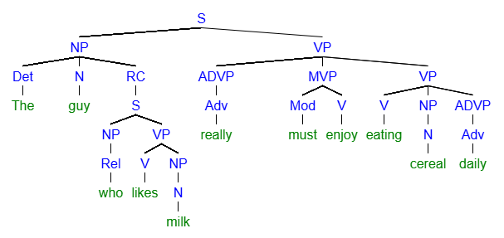
Question Twenty Three: (14 pts)
Twenty Three Part A: Complete the sentence labeling table below (7 pts)
Sentence: You should consider retiring if you leave early every day.
CLAUSE | Main/Independent |  |  |  | Dependent
ROLE | Subj | Pred |  | DO | --- | Subj | Pred |  | Advl
PHRASE | NP | VP |  | VP | --- | NP | VP |  | NP
WORD | You | Should | Consider | Retiring | If | You | Leave | Early | Every | Day
Part of Speech | Pro | Mod | V | V | Sub | Pro | V | Adv | Det | N

Twenty Three Part A: Diagram this sentence (7 pts)
Sentence: You should consider retiring when you leave early every day.
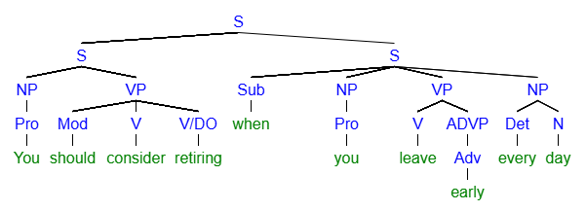
Question Twenty Four: (14 pts)
Twenty Four Part A: Complete this Sentence Labeling Table (7 pts)
Sentence: Anja can tell who loves him and who hates him.
CLAUSE | Main |  |  | Complement Clause |  |  | -- | Complement Clause
ROLE | Subj | Pred |  | DO |  |  | -- | DO
PHRASE | NP | VP |  | NP | VP | NP | -- | NP | VP | NP
WORD | Anja | Can | Tell | Who | Loves | Him | And | Who | Hates | Him
Part of Speech | N | Mod | V | Comp | V | Pro | Conj | Comp | V | Pro

Twenty Four Part B: Diagram this sentence (7 pts)
Anja can tell who loves him and who hates him.
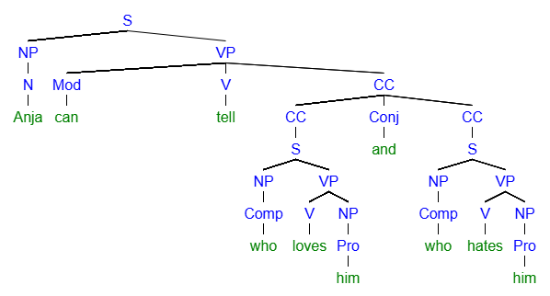
Section D: Bonus – Up to 18 points (3 points per question)
Rewrite the sentences below to correct the punctuation errors found in them. Punctuate using the most prescriptive grammatical rules for formal writing. Read the sentences as part of a paragraph (previous sentences provide context for later sentences).
- Sarah and Marshall happened upon a small cottage, and slept there to escape the rain.

- The cottage was warm and dry however they both felt an eerie presence.

- The cottage that was once owned by a shepherd was purported to be haunted.

- The shepherd an Irishmen named Fitzgerald had a penchant for dirges on the bagpipe.

- Playing the bagpipe was more popular at the time. Even though many locals still detested it.

- With the sounds of the ghostly bagpipes easing their nerves; Sarah and Marshall drifted into a dreamless slumber.

